CHAPTER 39
PARTICLES BEHAVING AS WAVES
Discussion Questions
Q39.1 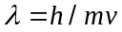. The electron has a smaller mass so has a larger .

Q39.2 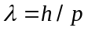. 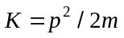, so 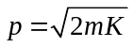. 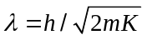. The electron has a smaller mass so has a larger .

Q39.3 For a photon . This is identical to Eq.(38.5) that relates the momentum of a photon to the wavelength of the light. The de Broglie wavelength of the photon and the wavelength of the associated electromagnetic wave are the same.

Q39.4 The electron remains a point particle. When the electron goes through the hole its position in the direction parallel to the hole is determined to within the diameter of the hole and by the uncertainty principle this introduces an uncertainty in the component of its momentum in the direction that is parallel to the hole. This uncertainty in transverse momentum causes a spread in the location where the electrons strike the screen.

Q39.5 To emit light in the 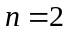 to 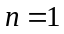 transition there needs to be atoms in the excited state. Galaxies contain a lot of atoms in the excited state so must have a high temperature. The intergalactic medium must have few atoms in the excited state so must be cold.

Q39.6 In the equations in Section 39.3 that describe the hydrogen atom replace 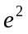 by 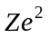to get the corresponding equations for a one-electron ion with atomic number . Eq.(39.14) shows that 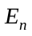 for hydrogen is proportional to 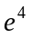, so the corresponding for Li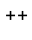 are larger by a factor of 9. Eq.(39.8) shows that for hydrogen is proportional to 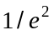so the corresponding for Li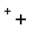 are smaller by a factor of 1/3.

Q39.7 A photon with energy 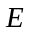 has momentum 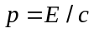. If the atom has mass 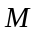 and gains momentum when the photon is emitted, the recoil kinetic energy is . 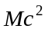 is the total rest mass energy of the atom. is the transition energy for the atom and is much, much less than the rest mass energy of the atom. for a proton is 938 MeV and is typically less than 10 eV, so 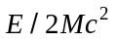 is very small. The recoil kinetic energy is a very small fraction of the photon energy and is negligible in Eq.(39.5).

Q39.8 It can be done, and has been done, in the Franck-Hertz experiment. This is described in Section 39.3.

Q39.9 For a gas of atoms the electrons in each atom are in discrete energy levels. For a solid there are electrons in bands of energies and the electrons can have any of the energies within these bands and there is a continuous spread of transition energies. See Section 42.4.

Q39.10 The intensity versus wavelength of the emitted light follows the Planck radiation law. This law (Fig.39.32 and Eq.39.24) and also the Wien displacement law (Eq.39.21) show that the spectral emittance 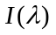 peaks at smaller wavelengths as the temperature of the object increases. This causes a shift in color. The underlying reason for the shift in is that at higher temperatures higher energy levels of the electrons in the solid are populated so emission can occur from these higher levels. Transitions from higher energy levels have greater transition energies and the emitted photons have higher energies and shorter wavelengths. Eq.(39.19) also shows that the total intensity of the emitted radiation increases as 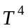.

Q39.11 If we apply Bohr’s angular momentum quantization to a planet, the quantum numbers are huge and orbits for successive are infinitesimal close in radius. No discrete nature of the orbit radius of the planet is observable.

Q39.12 The de Broglie wavelength of an electron with kinetic energy 54 eV is
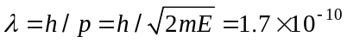 m. The wave nature of the electrons is of no consequence in this application.

Q39.13 Extremely short wavelength electromagnetic waves have very energetic photons that would damage the object being examined.

Q39.14 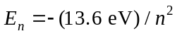 so an electron in a higher n shell has more energy. 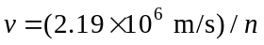. An electron in a higher n shell also has a smaller speed in its orbit and therefore less kinetic energy. But the electron with larger n has more (less negative) potential energy and this gives it more total energy. In fact, 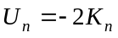, so 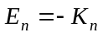 and smaller 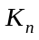 means greater 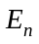 since is negative.

Q39.15 No. For 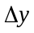 on the order of the diameter of the bullet, 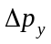 from the uncertainty principle is exceedingly small and produces no observable effects.

Q39.16 If one slit is covered a single-slit diffraction pattern is obtained, not a two-slit pattern. Both slits must be open for each electron so in this sense all electrons go through both slits. If we want to show the wave nature of electrons by observing an interference pattern in a two-slit experiment, we cannot at the same time show their particle nature by requiring the electrons to go through one slit or the other.

Q39.17 Eq.(39.30) says that the energy cannot be precisely measured in a very short time. Energy conservation can be violated only for very short times.

Q39.18 Eq.(39.30) says that the longer an atom is in an excited state, the more precise is the energy of that state and therefore the smaller the spread in transition energy when the atom makes a transition from the excited state to the ground state. The energy of the emitted photon equals the transition energy, so photons emitted in a transition from a long-lived atomic state have a narrower spread in energy and wavelength. For ordinary light sources the atoms are in the excited states for very short time intervals and the energy uncertainty of those states is large.
Q39.19 Yes, a grating of any number of slits could be used. The diffraction pattern would be the same as for light whose wavelength is the same as the de Broglie wavelength of the electrons; the electrons would strike the screen only within narrow lines on the screen. The uncertainty principle would not be violated. The greater the number of slits the more uncertain is the position of the electron when it passes through the grating so the more precise can be its direction of travel.

Q39.20 The aluminum foil is a polycrystalline material. It consists of randomly oriented microscopic crystals. For a single crystal a pattern like that shown in Fig.36.20 would be observed. The location of the dots depends on the orientation of the crystal relative to the electron beam. The pattern from the polycrystalline foil includes contributions from crystals of all orientations so each dot is replaced by a continuous ring of dots.

Q39.21 The resolution is determined by 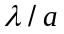, where is the lens diameter. The de Broglie wavelength of the electrons is orders of magnitude smaller than the wavelength of visible light. So the electron microscope is better able to resolve small objects. The magnification of a microscope is (approximately) = (25 cm)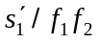 (Eq.34.24). To have a large magnification the focal lengths 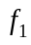 and 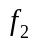 of objective and eyepiece must be very small. It is difficult to make extremely small focal length lenses for visible light. It is much easier to make small focal length electrostatic lenses for electrons.

Q39.22 When you measure the temperature of an object by inserting a thermometer into it you change the temperature of the object at least slightly because some heat is transferred between the object and the thermometer. If you measure the current in a circuit with an ammeter you add the ammeter resistance in series and alter the current you are trying to measure.

